Creating an AdventureWorksLT database on Azure

This guide can be used to create a database on Microsoft’s Azure cloud platform. The steps and screen shots are correct as of the time of publishing.

**As Azure is regularly updated and improved, there is a possibility that this guide may be out of date.**

**Before following the steps below, please follow the details of how to acquire a Microsoft Azure pass for you and your class here: http://go.microsoft.com/fwlink/?LinkId=512034**

# Logging into Azure

1. You will require a Microsoft account to login to the Azure Portal. The following steps assume you have already created these credentials.
2. On the Start menu, type **Internet Explorer**, and then click **Internet Explorer**.
3. In the address bar, type **portal.azure.com**, and then press Enter.
4. Enter your Microsoft account credentials to log in.

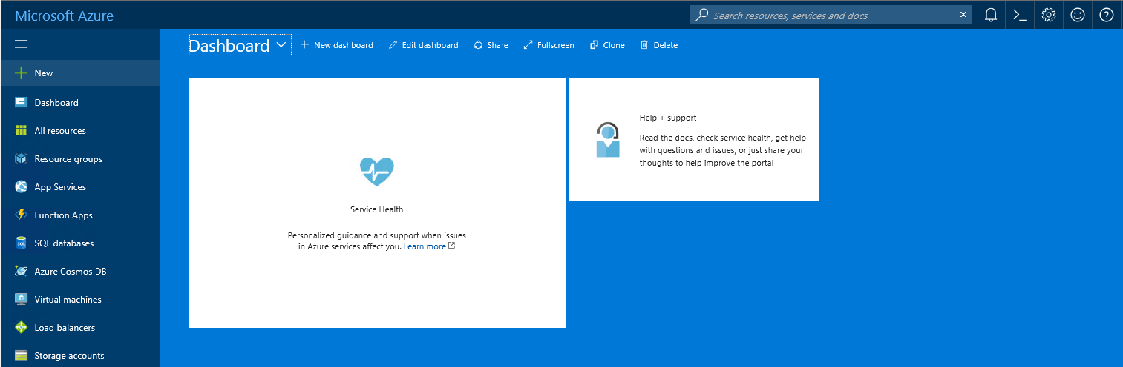

# Create a database containing AdventureWorksLT

The following steps create an SQL Server, and populates it with an example AdventureWorksLT database.

1. To open the **SQL databases** blade, click **SQL** **databases**.
2. Click **Add**, to open the **SQL Database** blade.

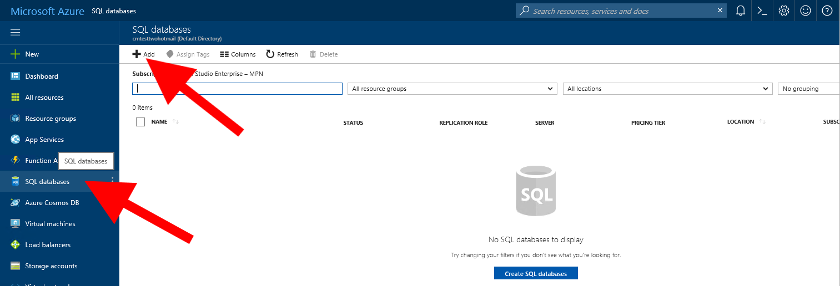

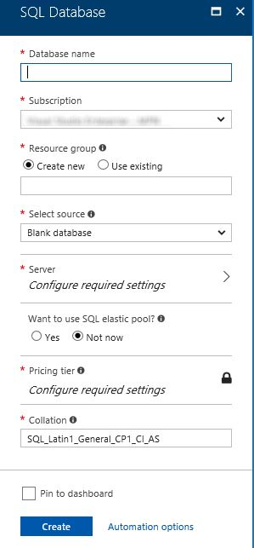

1. In the **Database name** box, type **AdventureWorksLT**.
2. In the **Resource group** box, enter the course number and a unique identifier, for example **20761a-azure**. If the name is taken choose another.
3. In the **Select source** list, click **Sample (AdventureWorksLT)**.
4. Click **Server**, to open the **Server** blade.
5. 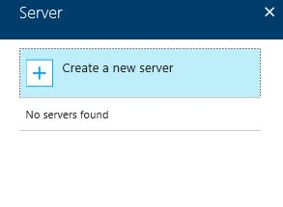Click **Create a new server**, to open the **New server** blade.

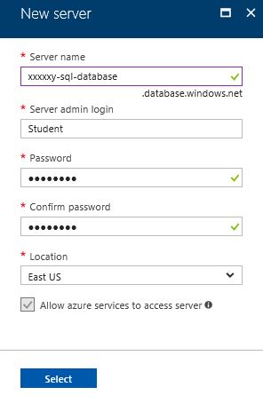

1. In the **Server name** box, enter the course number and a unique identifier, for example **xxxxxy-sql-database**. If the name is taken choose another.
2. In the **Server admin login** box, type **Student**.
3. In the **Password** box, type **Pa55w.rd**.
4. In the **Confirm** **password** box, type **Pa55w.rd**.
5. In the **Location** list, chose a location that is closest to you, and then click **Select**.

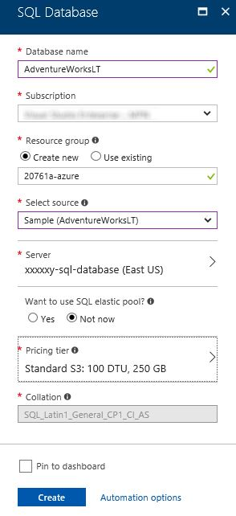

1. On the **SQL Database** blade, click **Create**.
2. Wait for the **Creating SQL Database** dialog to complete, this can take several minutes.

# Open the firewall to enable database connections

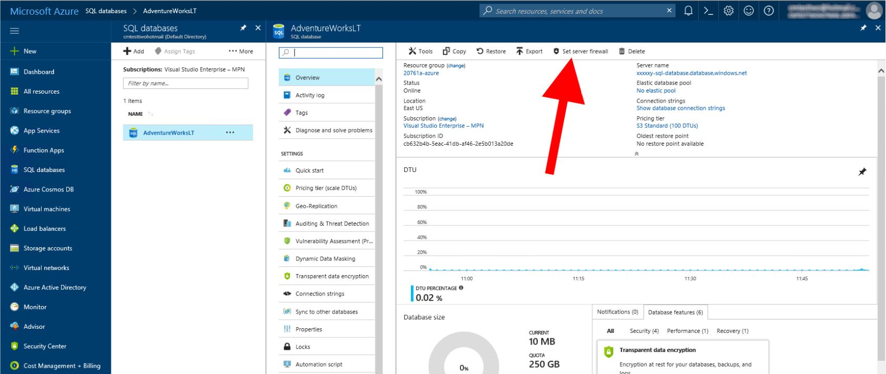

Now the SQL Server and database have been created, it is possible to setup the firewall to enable access to the Azure database through SQL Server Management Studio.

1. On the **AdventureWorksLT** blade, click **Set server Firewall**.
2. 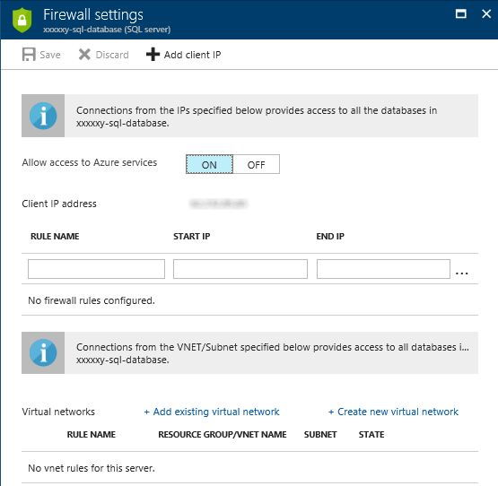On the **Firewall settings** blade, click **Add client IP**, and then click **Save**.
3. In the **Success** message box, click **OK**.
4. On the **Firewall settings** blade, click **Close** to return you to the **AdventureWorksLT** blade.